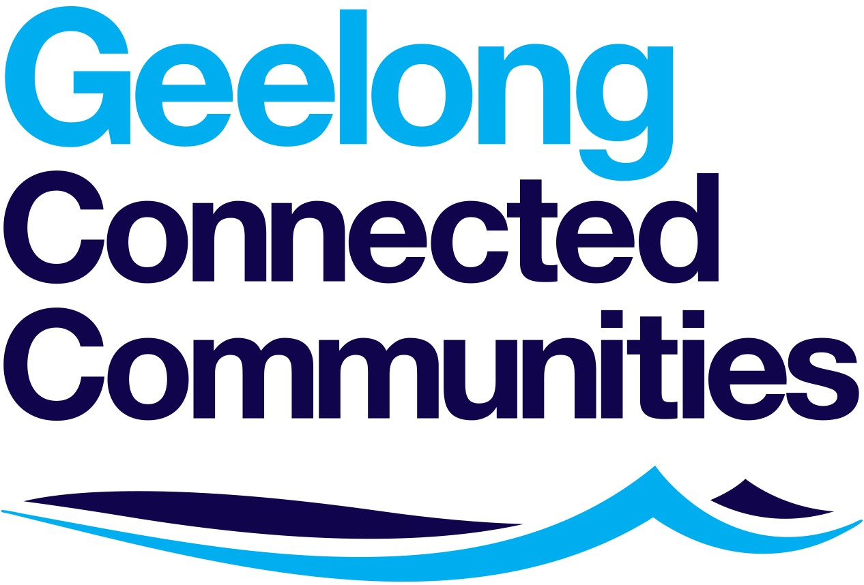

GRANT APPLICATION PROCEDURE OF GEELONG CONNECTED COMMUNITIES LTD. (GCC)

- Applications can be lodged at any time during the calendar year.
- Applications will be accepted from organisations with or without DGR status.
- Organisations are required to limit themselves to one grant application for each financial year.
- All applications are lodged electronically at info@geelongconnectedcommunities.com.au on the application forms housed on GCC’s website www.geelongconnectedcommunities.com.au.
- On receipt of each grant application, GCC acknowledges receipt of the application by return email and provides the applicant organisation with a copy of our company’s Grant Application Procedure.
- Grant applications are referred to 2 x GCC Directors who:
 Assess the application
 Check that the application meets our company’s advertised criteria
 Can refer applications to other directors for advice, if appropriate
 Recommend approval and amount of grant to GCC’s Board of Directors
- Larger applications are assessed and approved by GCC’s full Board of Directors.
- GCC Grants are generally not subject to GST. Grant applicants will be advised at the time of approval, if GST is applicable.
- On the approval of a grant application, the applicant organisation is advised of the approval in writing, and is invited to submit an invoice for payment of the approved amount.
- Upon receipt of an invoice for an approved grant application, unless otherwise advised at the time of approval, funds are provided immediately to the applicant organisation.
- All successful grant applicants are requested to provide GCC with an acquittal of its grant application within a nominated period from the date of funding, advising on the outcome of the purpose for which GCC’s funds were provided, and details of any activities of the applicant organisation in the promotion of Geelong Connected Communities.
- If the applicant organisation has not provided GCC with an acquittal for its past grants, payment of the current grant will not be funded until past acquittals are received.
- Upon payment of a grant application, GCC;
 Advertises the successful grant on its website
 Will post a notice on its facebook page
- GCC may seek a meeting with successful grant applicants to discuss its approved grant application.
- Some successful grant applications are chosen by our company’s Marketing Sub-Committee to feature in our company’s monthly video newsletter.
14. Subject to funding being available, it is GCC’s intention to provide each applicant organisation with an approval and funding within 60 days.
15. Decisions by the board on the fate of a grant application are final and correspondence will not be entered into. Organisations are requested not to resubmit previously unsuccessful applications.
16. Unsuccessful applicants are advised in writing within 30 days, and their
applications kept for 36 months, then destroyed.

